**ASSIGNMENT**

**Type convertion**

1.Convert an integer to a floating point number

Python's method float() will convert integers to floats. To use this function, add an integer inside of the parentheses:

In this case, 57 will be converted to 57.0 .

You can also use this with a variable. ...

By using the float() function, we can convert integers to floats.

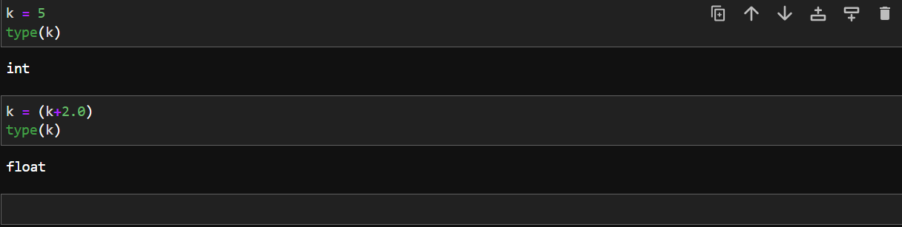

2.Convert an float to integer

To convert float into integer use () this function.

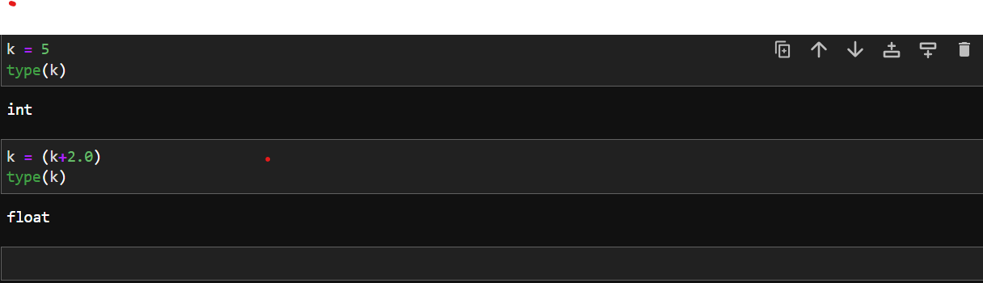

3.Convert string into int.

We can’t convert string into int

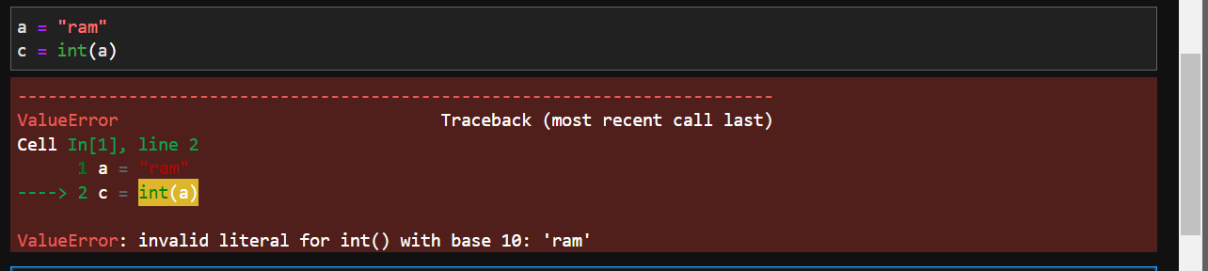

4.Convert a list into a Tuple

To convert a list to a tuple

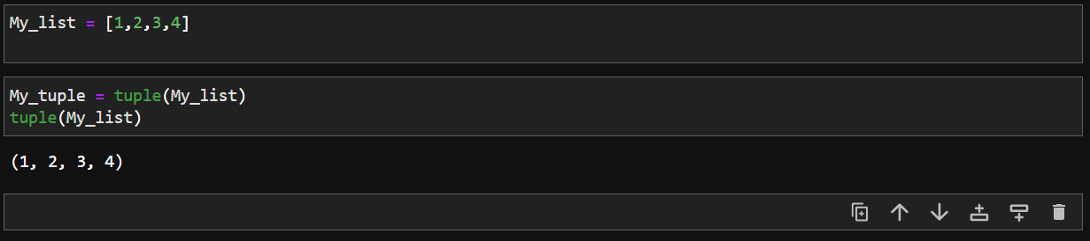

5. Convert tuple in to list.

We can convert a tuple into list using list() function.

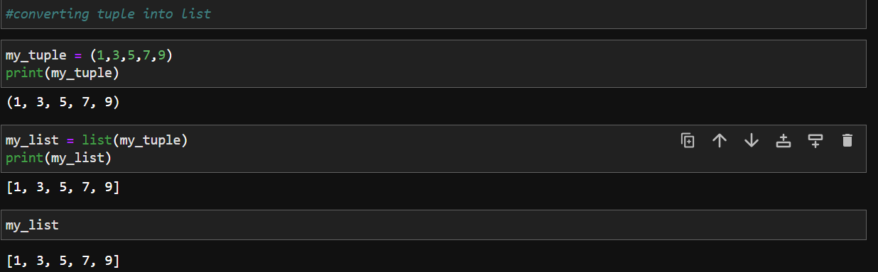

6.Convert a decimal number into binary.

To convert decimal to binary use a binary function ,then convert to decimal is shown in below.

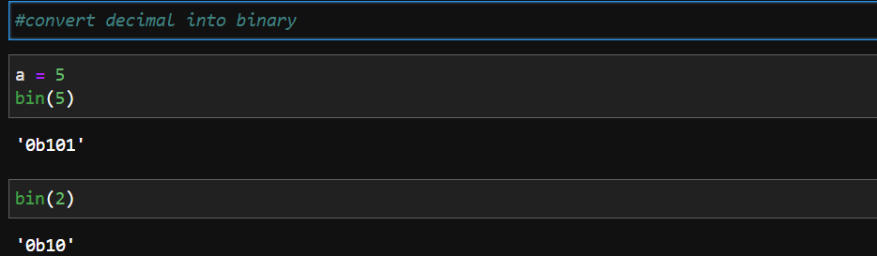

7.Convert a non zero number to Boolean

